Remember all commands on GIT starts with keyword “git”, if we want to configure the properties you need to mention “config”.

1. To configure the git user name globally, use the below command.

# git config --global user.name “Harikrishna ganji”



1. To configure the git email globally, use the below command.

# git config --global user.email [harikrishna862000@hotmail.com](mailto:harikrishna862000@hotmail.com)



1. To list all the properties that are configured globally, use the below command.

# git config --list

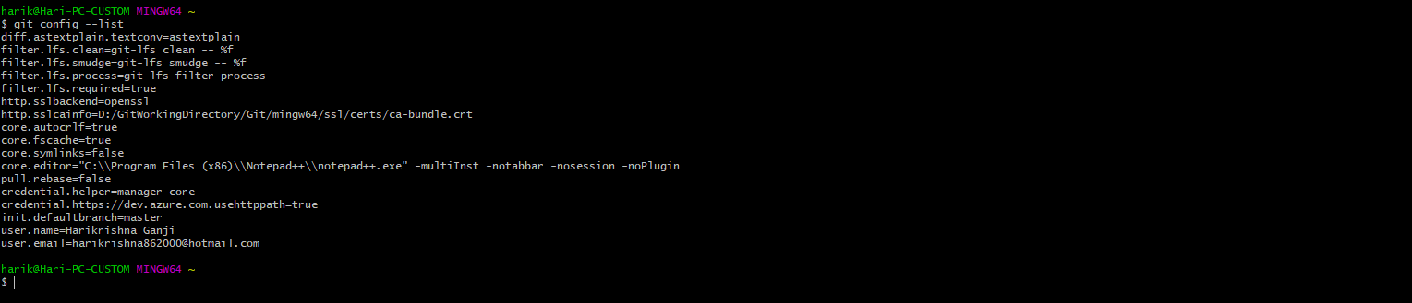

1. You can launch git help by using the below command.

# git help



1. If you want to get help of a single specific command, you can issue the below command it will launch a new command of a help for that command.

# git help <option>



